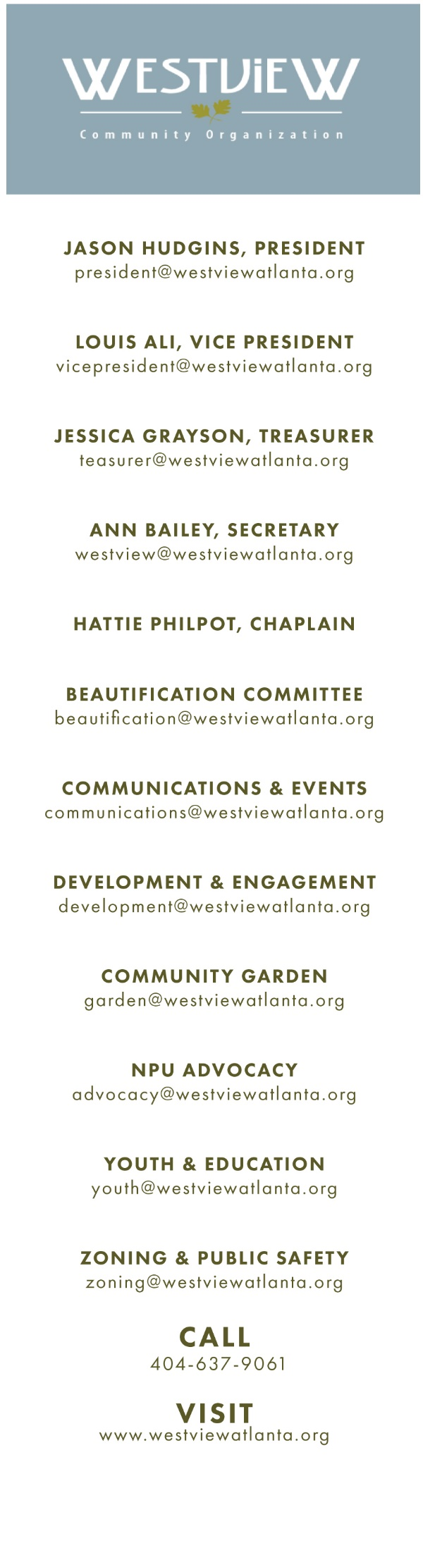­­­ W

**Westview Community Organization**

# January 6, 2020

# Calvary United Methodist Church

# 1471 Ralph David Abernathy Boulevard

# Call to Order

# Reflective Thoughts - Rosalyn Lamb

# Reading and Approval of the Minutes

# Zone 4 Public Safety Update

# Treasurer’s Report

# Old Business

# Westview Stormwater Initiative

# Westview Oral History Center

# Atlanta Preservation Center

# New Business:

# BZA – V-19-274, 1599 Linda Way

# BZA – V-19-267, 701 Waters Drive SW

# Special Use Permit - 1699 Westwood

# Committee Reports

# Events

# Beautification

# Vintage Westview Activists

# Engagement and Development

# NPU and Advocacy

# Youth and Education

# Zoning and Public Safety

# Executive

# Community Concerns, Questions and Announcements

# Adjournment

# Community Reminders

# NPU T Meeting 12/11 7pm – LEE + WHITE