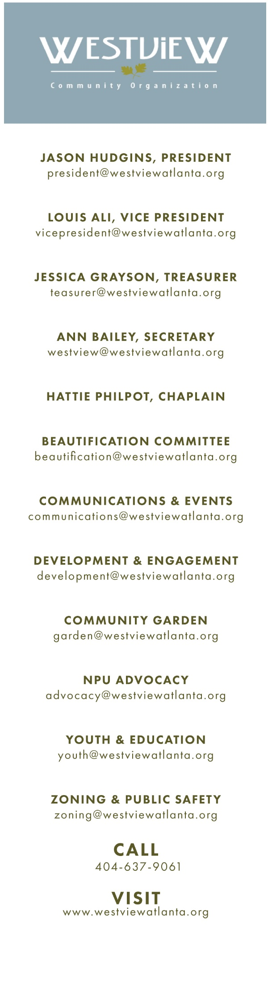­­­ W

**Westview Community Organization**

# May 3, 2021 - 7pm

# Virtual Meeting via [ZOOM](https://zoom.us/meeting/register/tJIsdu-vpjMsGNIZmpQC6Xz-RbBBNRCva90r)

# Call to Order

# Reflective Thoughts - Rosalyn Lamb

# Reading and Approval of the Minutes

# Public Safety Update

# Zone 4

# Public Safety Committee – Toya Lester

# Treasurer’s Report - Nir Levy

# Old Business:

# Westview University

# New Business:

# 525 Langhorn

# WCO/Emory Vaccination Event

# Community Marketing

# State Senator Sonya Halpern

# Senior Buddy Program

# Committee Reports

# Executive – Jason Hudgins, Dustin Mitchell-Scott

# Communications & Events – Ann Bailey

# Zoning – Doug Stine

# Beautification – Winston Mitchell-Scott

# Westview Votes – Jill Alikonis

# Development – Shayna Barley

# NPU & Advocacy – Robyn Turner

# Youth – Kimberly Boykin

# Seniors – Wesley Benjamin

# Community Concerns, Questions and Announcements

# Adjournment

# Community Reminders

# 5/12 WCO/Emory Vaccination Event 11am – 3pm Pathways Church, Lucille and RDA

# 5/12 NPU-T Meeting 7pm via zoom – www.nputatlanta.com

# 6/7 June WCO Meeting 7pm via ZOOM

**Jason Hudgins, President**

**President@westviewatlanta.org**

**Dustin Mitchell-Scott, Vice President**

**Vicepresident@westviewatlanta.org**

**Erica Broadwater, Scribe**

**Westview@westviewatlanta.org**

**Nir Levy, Treasurer**

**Treasurer@westviewatlanta.org**

**Rosalyn Lamb, Chaplain**

**Beautification Committee**

**Beautification@westviewatlanta.org**

**Communication & Events**

**Communications@westviewatlanta.org**

**Development & Engagement**

**Development@westviewatlanta.org**

**NPU & Advocacy**

**Advocacy@westviewatlanta.org**

**Youth & Education**

**Youth@westviewatlanta.org**

**Seniors**

**Seniors@westviewatlanta.org**

**Zoning**

**Zoning@westviewatlanta.org**

**Public Safety**

**PublicSafety@westviewatlanta.org**

**Westview Votes**

**WestviewVotes@westviewatlanta.org**

**Call**

**404-637-9061**

**Visit**

**www.westviewatlanta.org**